INSTALL CLOUD CLI

**STEP 1 :**  iex (New-Object Net.WebClient).DownloadString('https://clis.cloud.ibm.com/install/powershell')

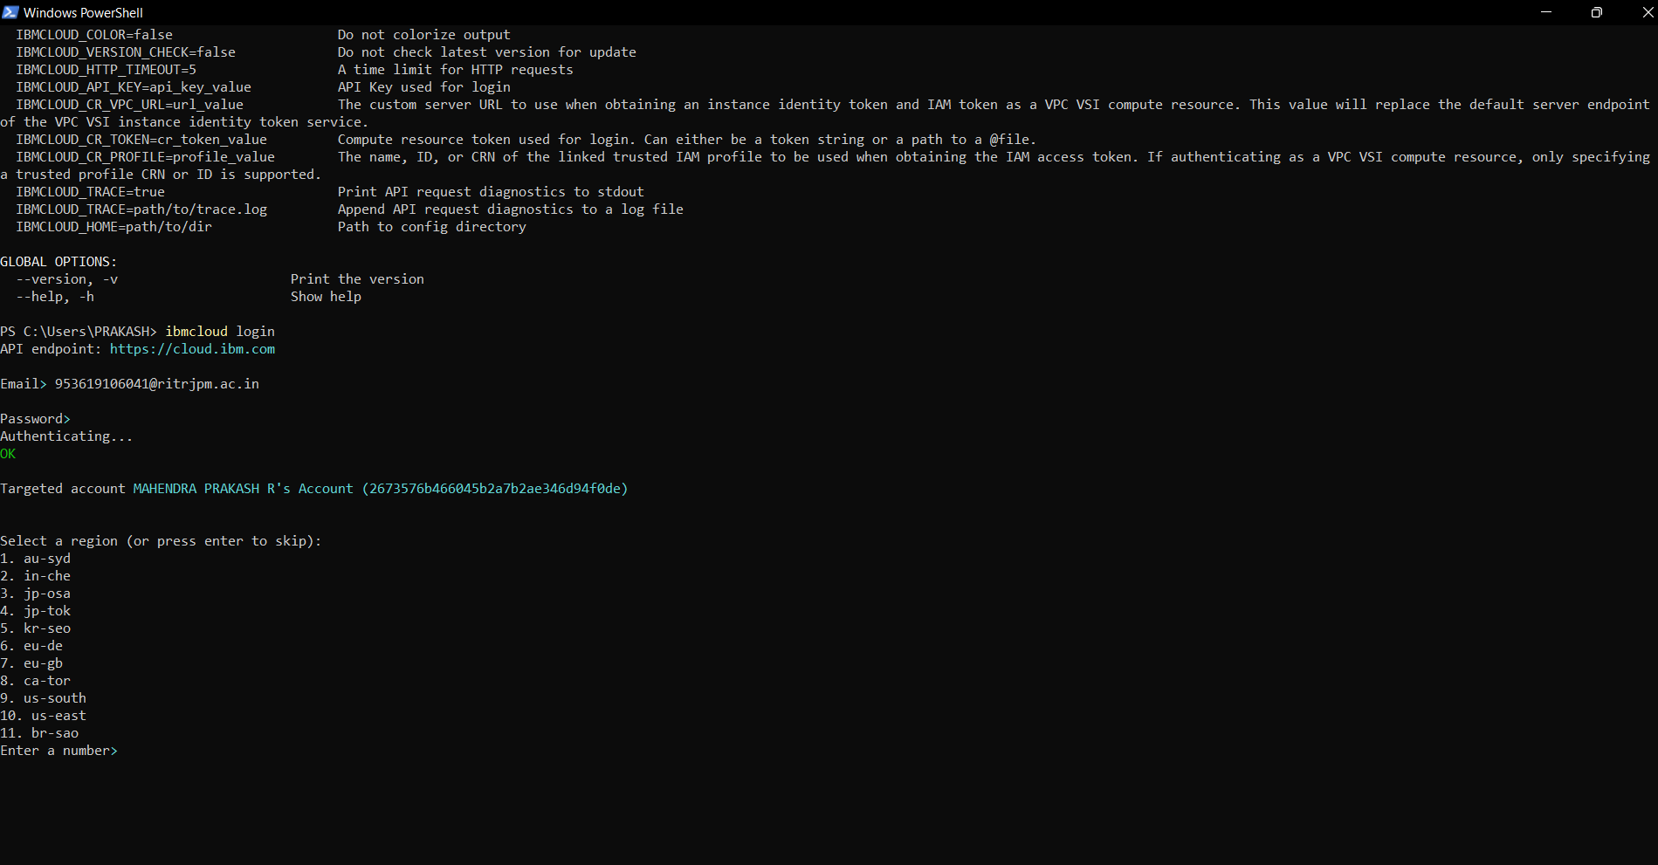

**STEP2 :**

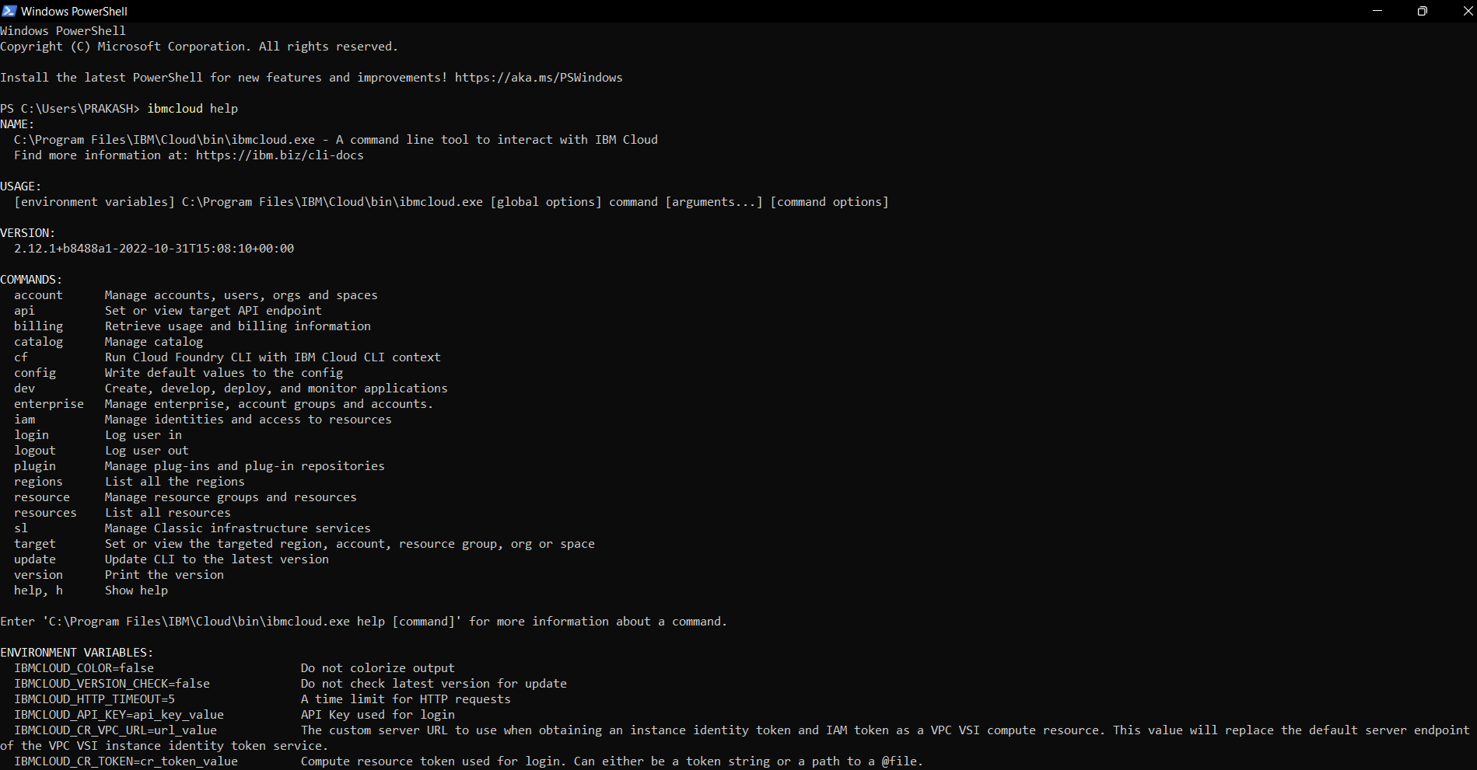

**STEP 3: LOGIN**

